1. Install Wordpress in Local Host

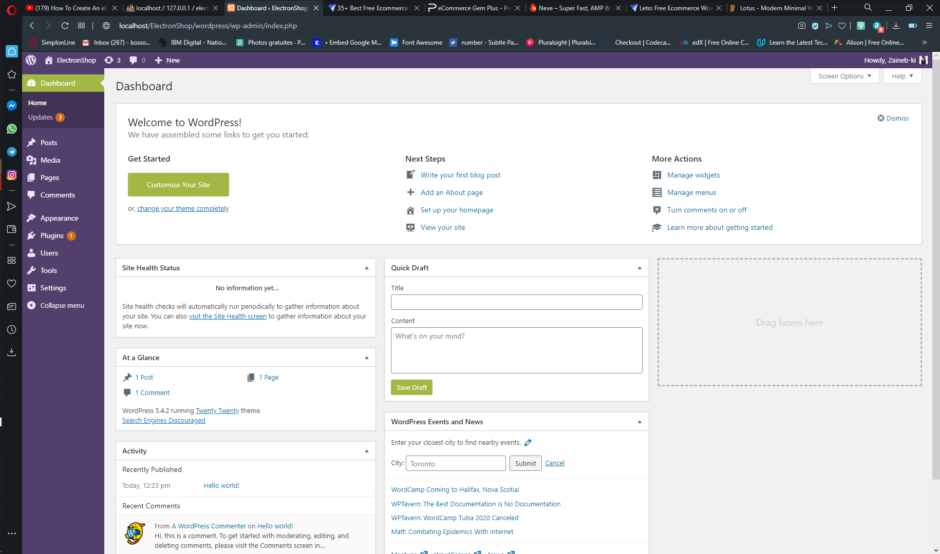

1. Choosing a Template and install it, I choose ‘LETO’



1. Now, I uploaded the themes in my work place

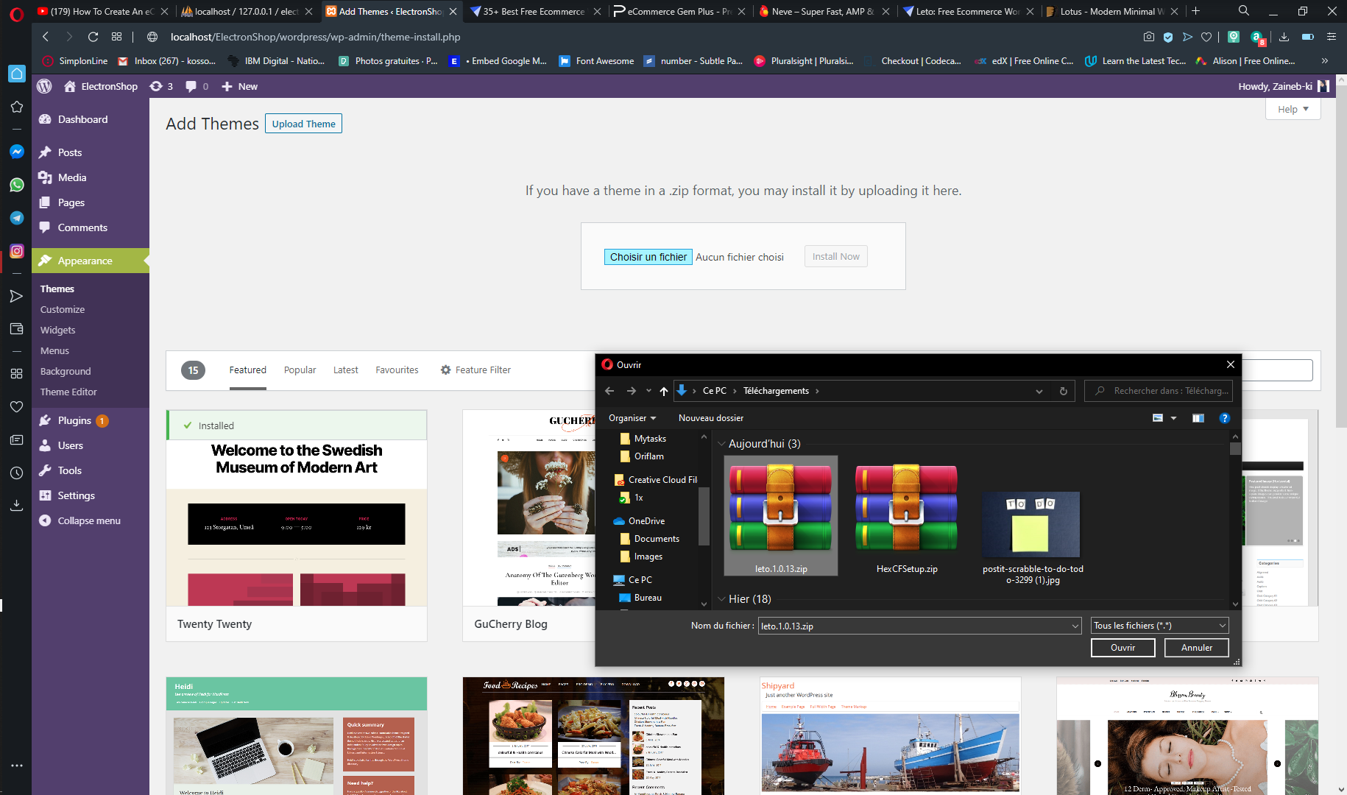

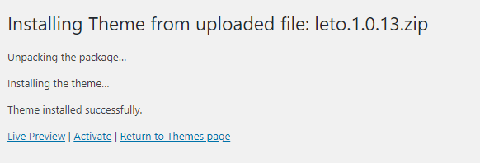

1. Next step, we should Activate Our Theme

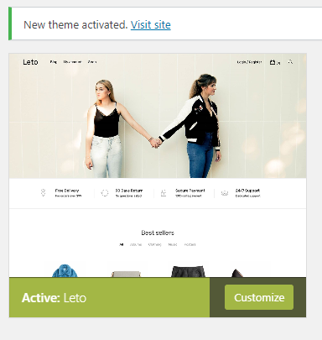

1. Now we start creating pages that we need in our web-site, Ex Home, About Us …

